CSE3506 Essentials of Data Analytics

Name : Revanth Bhargava Boyidi
Reg. No. : 19BCE1177
Lab Exercise: 6-Naive Bayes
Objective: To formulate a Naive Bayes classifier model for the the given dataset
Methods:
- Import the dataset
- Understand the data by plotting
- Splitting of data into train and test data
- Formulating the naive bayes classifier model using train data
- Predict the values for test data
- Find the accuracy of the model build
- Conclusions

Importing Libraries
setwd("D:\\SEM-VI\\EDA_CSE3506\\Lab\\Lab-6(09-04)_Naive Bayes")
rm(list=ls()) #To clear the environment
#install.packages('naivebayes')
#install.packages('psych') #For personality research
#install.packages('dplyr')
library(naivebayes)
## Warning: package 'naivebayes' was built under R version 4.1.3
## naivebayes 0.9.7 loaded
library(dplyr)
##
## Attaching package: 'dplyr'
## The following objects are masked from 'package:stats':
##
## filter, lag
## The following objects are masked from 'package:base':
##
## intersect, setdiff, setequal, union
library(ggplot2)
library(psych)
## Warning: package 'psych' was built under R version 4.1.3
##
## Attaching package: 'psych'
## The following objects are masked from 'package:ggplot2':
##
## %+%, alpha
Importing Dataset
dt<-read.csv('Lab Task 6.csv')
str(dt)
## 'data.frame': 400 obs. of 4 variables:
## $ gre : int 380 660 800 640 520 760 560 400 540 700 ...
## $ gpa : num 3.61 3.67 4 3.19 2.93 3 2.98 3.08 3.39 3.92 ...
## $ rank : int 3 3 1 4 4 2 1 2 3 2 ...
## $ admit: int 0 1 1 1 0 1 1 0 1 0 ...
dt$admit<-as.factor(dt$admit)
dt$rank<-as.factor(dt$rank)
Understanding the data
pairs.panels(dt) # to check the independence of attributes among them
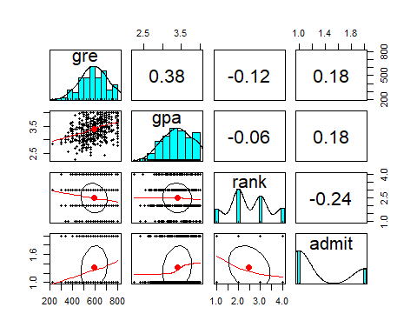
dt %>% # to have initial look up of
ggplot(aes(x=admit,y=gre,fill=admit))+
geom_boxplot()+
ggtitle('Admit Box Plot based on GRE Score')
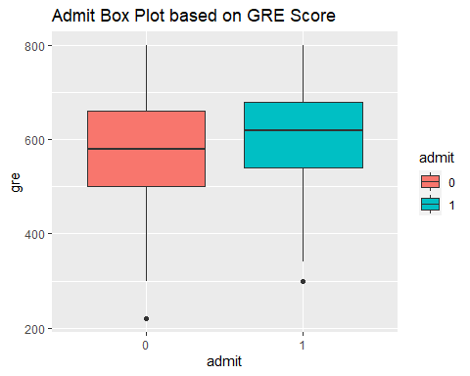
dt %>%
ggplot(aes(x=gre,fill=admit))+
geom_density(alpha=0.75,color='black')+
ggtitle('Density Plot based on GRE Score')
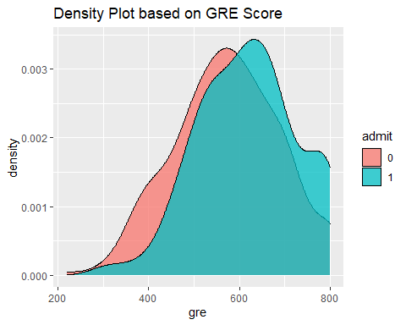
Splitting Dataset into Training data and Test data
The train-test split is a technique for evaluating the performance of a machine learning algorithm. It can be used for classification or regression problems and can be used for any supervised learning algorithm. The procedure involves taking a dataset and dividing it into two subsets.
set.seed(234)
smpl<-sample(2,nrow(dt),replace=T,prob=c(0.8,0.2))
train<-dt[smpl==1,]
test<-dt[smpl==2, ]
#P(Admit=1|Rank=1)= P(Admit=1)*P(Rank=1|Admit=1)/P(Rank=1)
mdl<-naive_bayes(admit~ .,data=train)
mdl
##
## ================================== Naive Bayes ==================================
##
## Call:
## naive_bayes.formula(formula = admit ~ ., data = train)
##
## ---------------------------------------------------------------------------------
## Laplace smoothing: 0
##
## ---------------------------------------------------------------------------------
##
## A priori probabilities:
##
## 0 1
## 0.6982249 0.3017751
##
## ---------------------------------------------------------------------------------
##
## Tables:
##
## ---------------------------------------------------------------------------------
## ::: gre (Gaussian)
## ---------------------------------------------------------------------------------
##
## gre 0 1
## mean 574.7458 617.4510
## sd 116.8211 110.9695
##
## ---------------------------------------------------------------------------------
## ::: gpa (Gaussian)
## ---------------------------------------------------------------------------------
##
## gpa 0 1
## mean 3.3350424 3.4896078
## sd 0.3754617 0.3745966
##
## ---------------------------------------------------------------------------------
## ::: rank (Categorical)
## ---------------------------------------------------------------------------------
##
## rank 0 1
## 1 0.10169492 0.28431373
## 2 0.35593220 0.42156863
## 3 0.33898305 0.21568627
## 4 0.20338983 0.07843137
##
## ---------------------------------------------------------------------------------
plot(mdl)
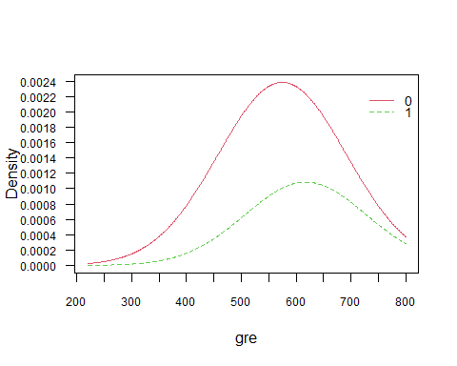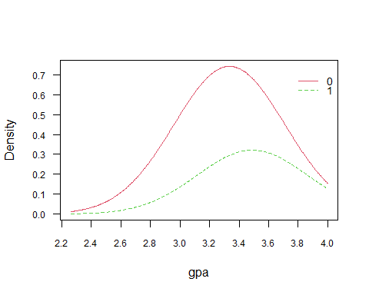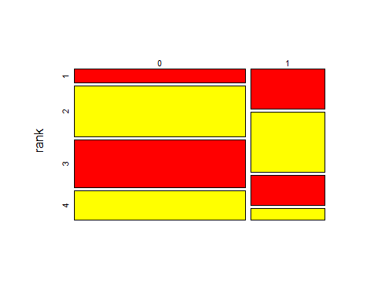
p<-predict(mdl,train,type='prob')
## Warning: predict.naive_bayes(): more features in the newdata are provided as
## there are probability tables in the object. Calculation is performed based on
## features to be found in the tables.
head(cbind(p,train))
## 0 1 gre gpa rank admit
## 1 0.8722071 0.12779286 380 3.61 3 0
## 2 0.6818999 0.31810012 660 3.67 3 1
## 3 0.1995820 0.80041802 800 4.00 1 1
## 4 0.8638849 0.13611511 640 3.19 4 1
## 5 0.9274275 0.07257251 520 2.93 4 0
## 6 0.6546716 0.34532836 760 3.00 2 1

Evaluating the Naives Bayes Model
Naïve Bayes algorithm is a supervised learning algorithm, which is based on Bayes theorem and used for solving classification problems. It is not a single algorithm but a family of algorithms where all of them share a common principle, i.e. every pair of features being classified is independent of each other.
#To find the accuracy of prediction on train data
p1<-predict(mdl,train)
## Warning: predict.naive_bayes(): more features in the newdata are provided as
## there are probability tables in the object. Calculation is performed based on
## features to be found in the tables.
(tab1<-table(p1,train$admit))
##
## p1 0 1
## 0 213 73
## 1 23 29
1-sum(diag(tab1))/sum(tab1)
## [1] 0.2840237
The mis-classification in train data is 0.28%.

Evaluating Test Data
Accuracy is the measurement used to determine which model is best at identifying relationships and patterns between variables in a dataset based on the input, or training data.
#To find the accuracy of prediction on test data
p2<-predict(mdl,test)
## Warning: predict.naive_bayes(): more features in the newdata are provided as
## there are probability tables in the object. Calculation is performed based on
## features to be found in the tables.
(tab2<-table(p2,test$admit))
##
## p2 0 1
## 0 34 19
## 1 3 6
1-sum(diag(tab2))/sum(tab2)
## [1] 0.3548387
The mis-classification in test data is 0.35%.
Conclusions
Naive Bayes classifiers are a family of simple "probabilistic classifiers" based on applying Bayes' theorem with strong (naive) independence assumptions between the features. The mis-classification in test data is 0.35%. This can be improved by cleaning the data, removing outliers, unnecessary rows, etc.

